**Data Stewardship Task Force  
Minutes**

**Wednesday, May 5, 2021**

**2:00 p.m. to 3:00 p.m.**

**Zoom**

**Present:** Xiaohong Li, Sherry Anderson, Olga Newlove, Danielle Vohnout, Kevin Kasper, and Amanda Bauer

**Absent:**  Darcy Bogle, Barbara Amerio, Rebecca Murillo and Tiffany Rowden

**Secretary:** Brandy Young

The minutes from April 7, 2021 were reviewed. Correction: Kevin Kasper will be added to the list of members present.

SCFF Data Flow Review

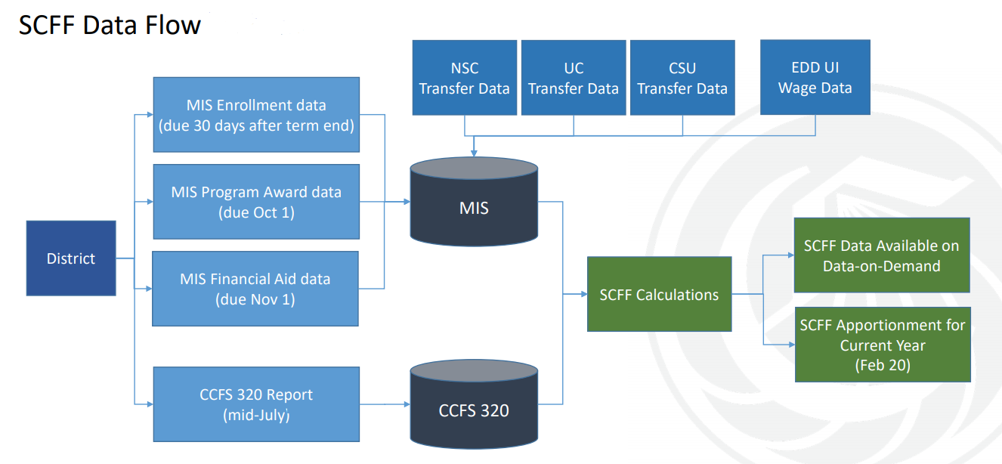

Xiaohong gave an overview of the above diagram. This diagram is from the Chancellor’s office. It represents the flow of data for SCFF calculations.

Review and Discussion of Audit Requirement

We currently have a practice in place for data management, but there is no current documentation on policy and procedure. The MIS reporting data governance and flow of data have been

established, but this still needs to be developed for the 320 Report. Amber Anderson is assisting with this. The auditors requested more detailed information this year, but we were able to demonstrate compliance with the current work that has been done by this task force.

Review Audit Procedures Data Management Practice Review

* Establish the expectation for shared ownership of data management responsibilities at the executive level and communicate this expectation to all departments. (Completed)
* Roles and responsibilities (Completed)
* Data Flow (Completed)

The items below will be the task of the new committee.

* Data definitions
* Accuracy and Completeness
* Training
* Communication

A new committee will be formed and will start to meet in fall of 2021. The committee will include faculty membership as well as executive level participation. The main focus will be to establish written policy and procedures for all data management components.

**Xiaohong thanked all members of the DSTF for all of their hard work. A lot was accomplished in bringing the College into compliance with data management practices.**

**Respectfully submitted by: Brandy Young**