

**Data Stewardship Task Force**

**Agenda**

**Wednesday, May 5, 2021**

**2:00 p.m. to 3:00 p.m.**

**Zoom**

[Join Zoom Meeting](https://cccconfer.zoom.us/j/97912109600?from=addon)

1. Review Last meeting’s minutes.
2. SCFF Data Flow Review

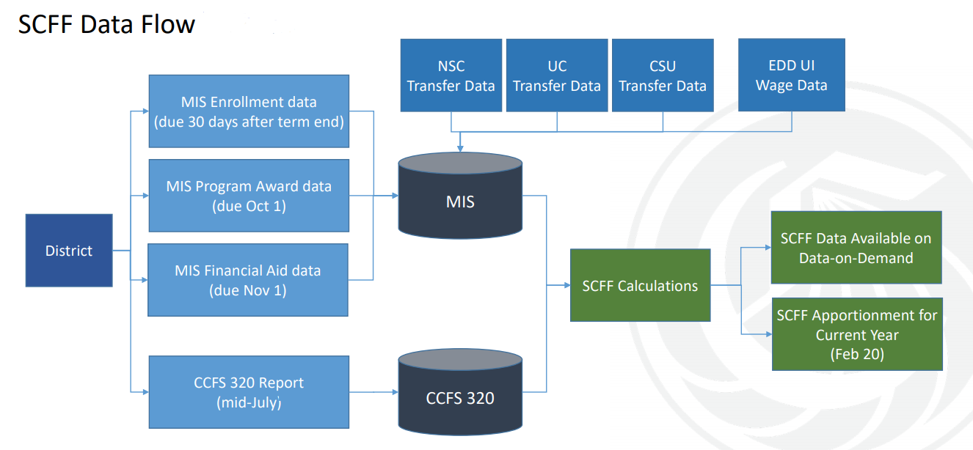

1. Review and Discussion of Audit Requirement

<https://www.cccco.edu/-/media/CCCCO-Website/College-Finance-and-Facilities/Manuals/CDAM-Manuals-2021/cdam202021finala11yUPDATED-0329.pdf?la=en&hash=9A0392699099A6F291E45BDFC8F2FC45241592B9>

Compliance Requirement

Districts should demonstrate adequate oversight of data management practices including, but not limited to:

Policies and procedures over SCFF data management should be implemented, adhered to, and maintained to ensure that data collected and reported to the Chancellor’s Office through MIS and the CCFS-320 Attendance Accounting portals are accurate and complete.

Responsibilities for SCFF data management should be clearly defined and assigned.

Information systems used to collect and report SCFF data should be monitored and maintained to ensure that timely, accurate, and reliable SCFF data is available for planning, decision making, and budgetary control.

1. Review Audit Procedures Data Management Practices Review

Establish the expectation for shared ownership of data management responsibilities at the executive level and communicate this expectation to all departments.

Roles and responsibilities

Data Flow

Data definitions

Accuracy and Completeness

Training

Communication

1. Next Step