**Data Governance Committee**

**Minutes**

**Thursday, December 2, 2021**

**2:00 p.m. to 3:00 p.m.**

**S-11**

Present: Amanda Bauer, Barbara Amerio, Jennifer Altenhofel, Krystal Allikas,   
Leslie Minor, Rebecca Murillo, Sharyn Eveland, Sherry Anderson, and Xiaohong Li

Absent: Damon Bell

Secretary: Brandy Young

Xiaohong opened the meeting with a brief overview of the role of the Data Standards Task Force and what that group accomplished. She summarized the MIS and 320 reports, the role of the Chancellor’s office and clarified acronyms within the SCFF Data Flow chart.

Review DSTF Charter  
The DSTF Charter will be adopted for this new committee. College-wide data will be the expanded focus of the new committee not just MIS reporting. Membership will be updated as follows:

* Vice President of Information and Institutional Effectiveness (Chair)
* Senior Research Assistant of IR & Planning (Secretary)
* Academic Senate Representative
* DBA/Senior Programmer Analyst
* Director of Financial Aid and Scholarships
* Director of Admissions & Records
* Educational Equity Data Specialist
* Fiscal Services Representative
* User Support Specialist
* Vice President of Instruction or Designee
* Vice President of Student Services or Designee

Name of the Committee: Data Standard/Data Governance/Data Design????

The new name of the Committee will be the Data Governance Committee. This is an operational committee.

Data Government Roles & Responsibilities review

Points of discussion:

* Changes to what data are available; for example, EW in success rates
* Data definitions
* Documentation and shared information to departments who report data
* Oversight of data entry into Banner – consistency in module fields

SCFF Data Flow Review

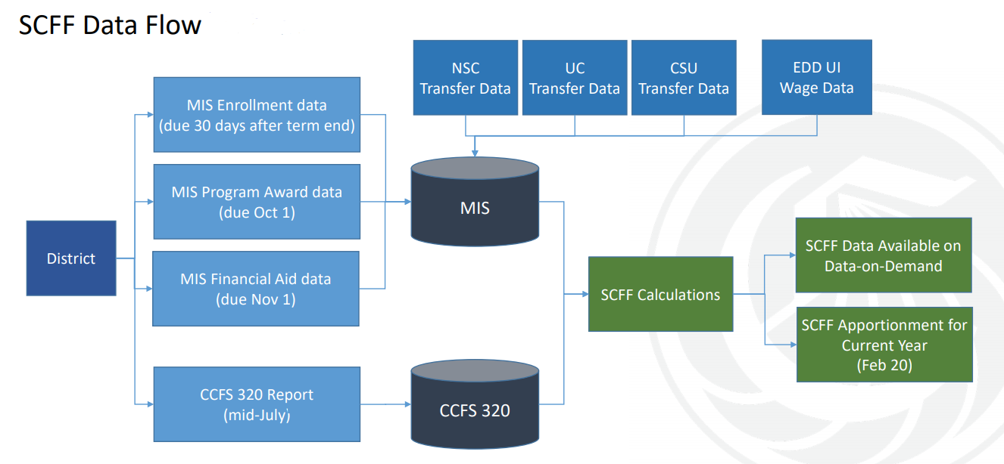

**The next meeting is scheduled for March 3, 2022 at 2:00 p.m. The location is TBD.**

Respectfully submitted by Brandy Young